Homework Report

Digital Image Processing: Computer Assignment 1

1. Histogram and Object Moment

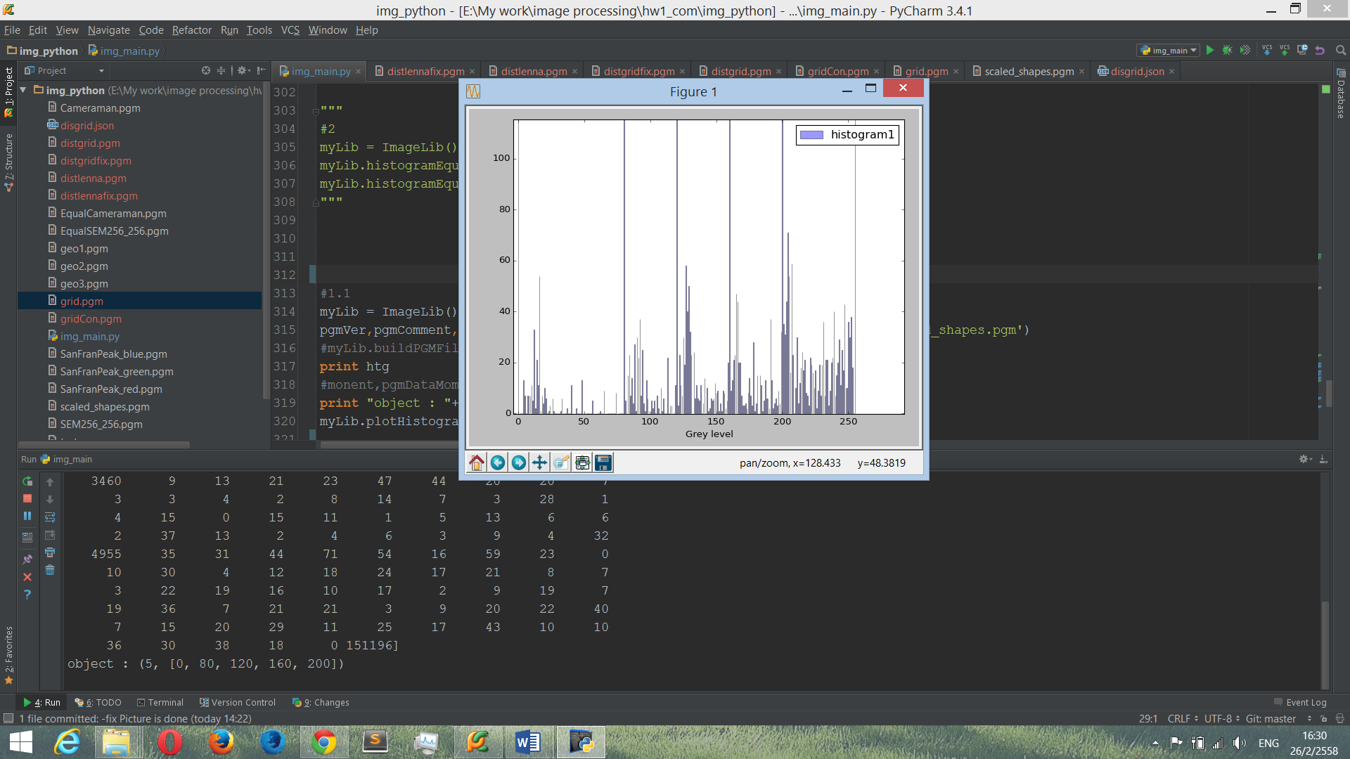

รูปที่ 1.1 Histogram

**Example code from my library**

myLib = ImageLib()

pgmVer,pgmComment,pgmSize,pgmGreyscale,pgmData,htg = myLib.readPGMImage('scaled_shapes.pgm')

*# pgmData is array that contain grey scale data of each pixel in picture*

*# htg is array that contain histogram data of each grey level*

print "object : "+ str(myLib.countingObject(htg,1000))

*# return object counting array. Second parameter is threshold value.*

myLib.plotHistogramFromArray(htg) *# call plot histogram function*

รูปที่ 1.1 คือ histogram ได้จากรูป scaled_shapes.pgm ซึ่งถ้าเรากำหนด Threshold ให้ว่าถ้าจำนวน histogram ของ Grey level ที่มีขนาดมากกว่า 1000 pixel เราจะพบว่า มีกราฟแท่งที่สูงกว่า Grey Level อื่นอยู่ 6 แท่ง นั้นเราสามารถสรุปได้ว่า Grey level ที่สูงกว่าแท่งอื่นแบบกระโดดมานั้น ประกอบด้วย Object อยู่ 5 แท่งที่มี Grey level ดังนี้ [0, 80, 120, 160, 200] และเป็น Background อยู่ 1 แท่งและมี Grey level คือ [ 255 ]

**Example code from my library**

myLib = ImageLib()

pgmVer,pgmComment,pgmSize,pgmGreyscale,pgmData,htg = myLib.readPGMImage('scaled_shapes.pgm')

print myLib.pqMoment(0,2,pgmData,pgmSize,pgmGreyscale,0) *# return pq-moment*

print myLib.centralMoment(2,0,pgmData,pgmSize,pgmGreyscale,0) *# return central moment*

print myLib.scaleInvariantMoment(2,0,pgmData,pgmSize,pgmGreyscale,0)+myLib.scaleInvariantMoment(0,2,pgmData,pgmSize,pgmGreyscale,0),80) # return quantity

Object 1 Grey Level: 0

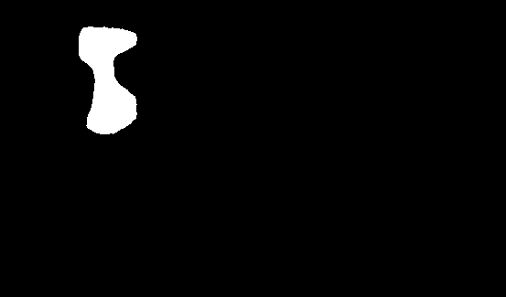

Result

* Center of mass : 116.130408533 , 85.512980479
* Central moment : (2,0) 1100035.49527 , (0,2) 6345057.41276
* Quantity : 0.301531111245

Object 2 Grey Level: 80

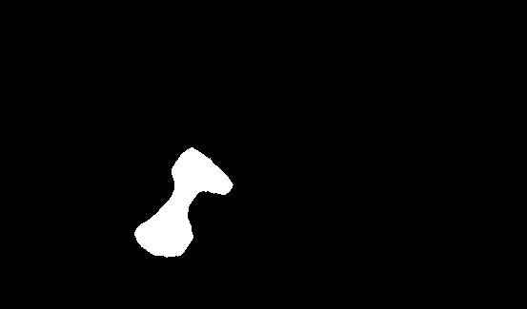

Result

* Center of mass : 189.080306699 , 215.044995964
* Central moment : (2,0) 2456890.03793 , (0,2) 4941000.9659
* Quantity : 0.301193318142

Object 3 Grey Level: 120

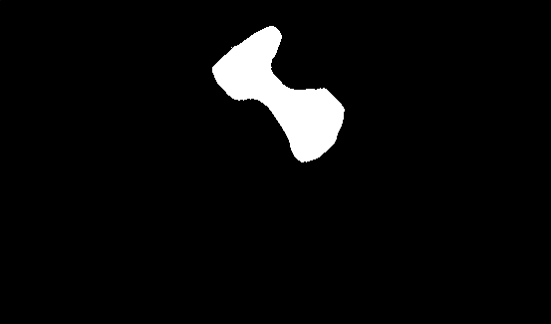

Result

* Center of mass : 280.547748705 , 95.1498206933
* Central moment : (2,0) 8460663.08434 , (0,2) 7875173.00226
* Quantity : 0.288181948056

Object 4 Grey Level: 160

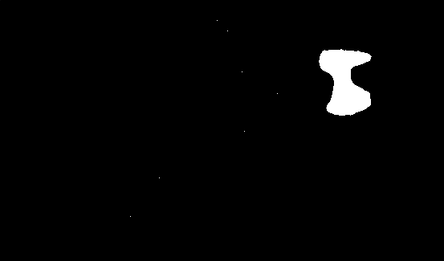

Result

* Center of mass : 428.010404624 , 100.979768786
* Central moment : (2,0) 975991.625434 , (0,2) 2194070.58382
* Quantity : 0.26479854065

Object 5 Grey Level: 200

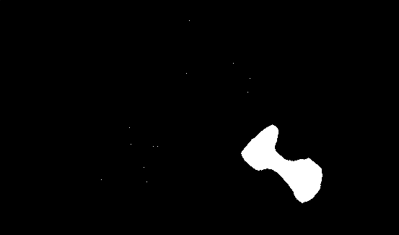

Result

* Center of mass : 391.438748739 , 227.531382442
* Central moment : (2,0) 4792344.16024 , (0,2) 3007131.87003
* Quantity : 0.317671394937

1. Point Operations

**Example code from my library**

myLib = ImageLib()

myLib.histogramEqualization("EqualCameraman","Cameraman")

myLib.histogramEqualization("EqualSEM256_256","SEM256_256")

Before After

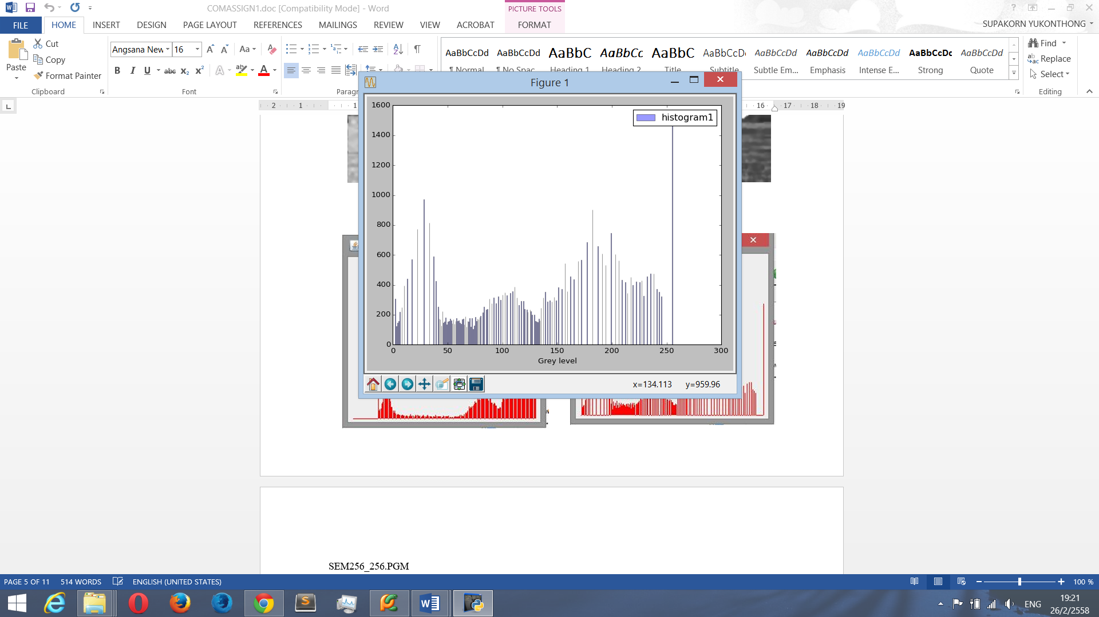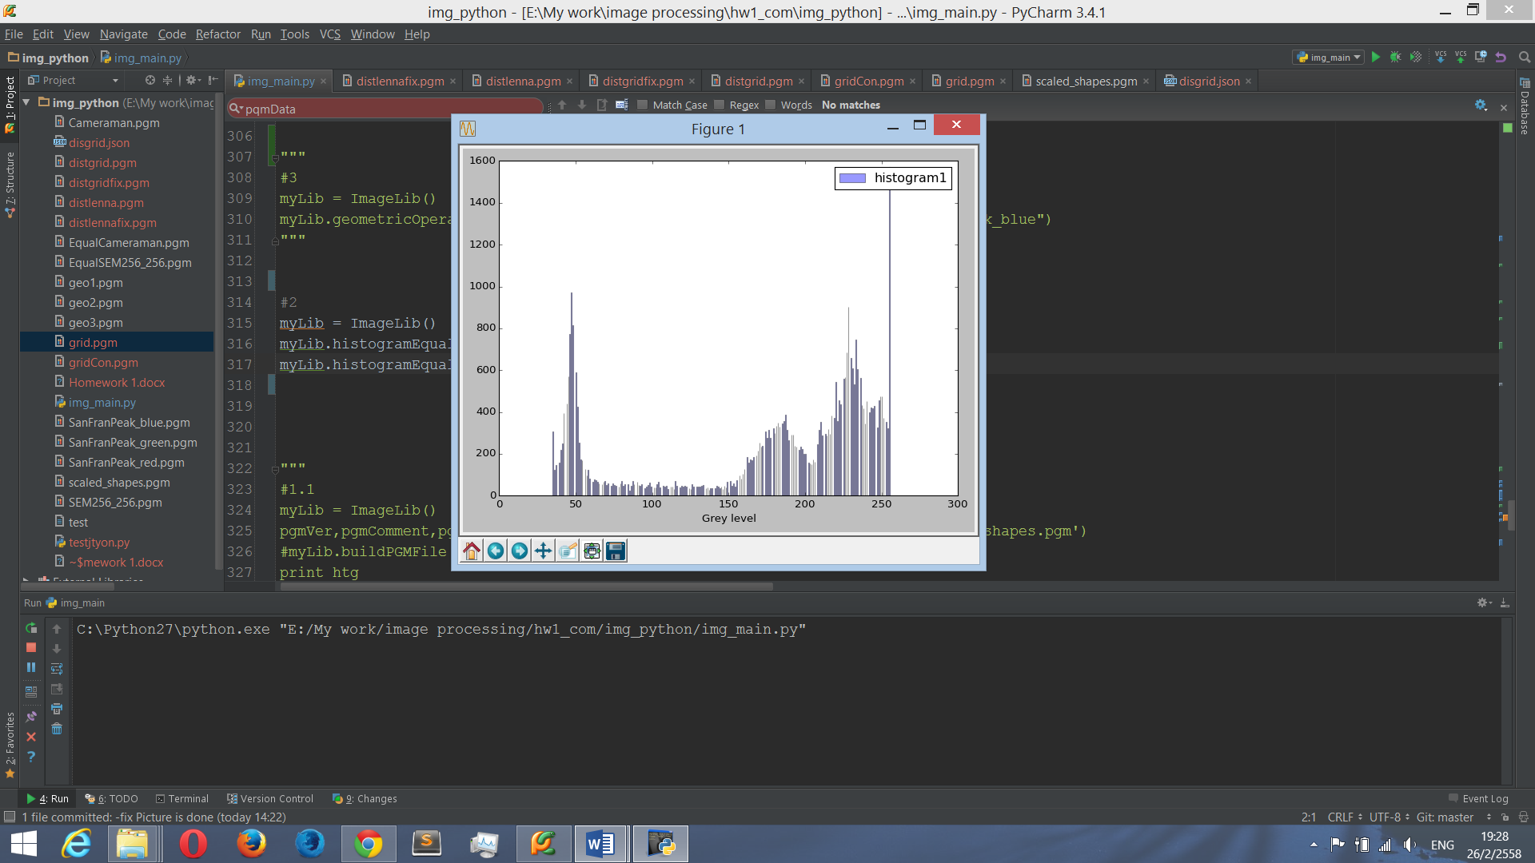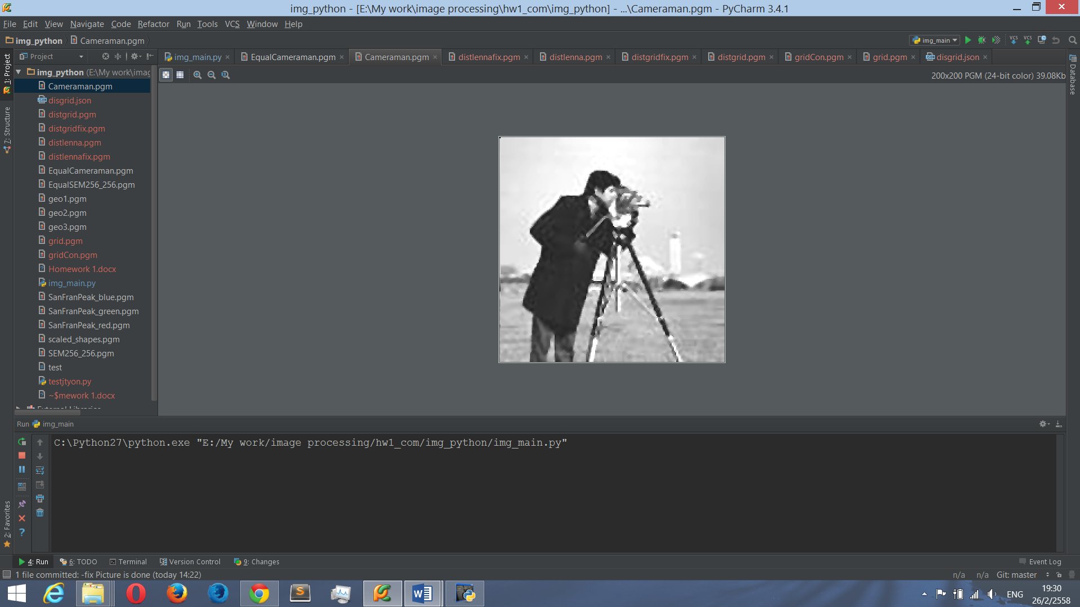

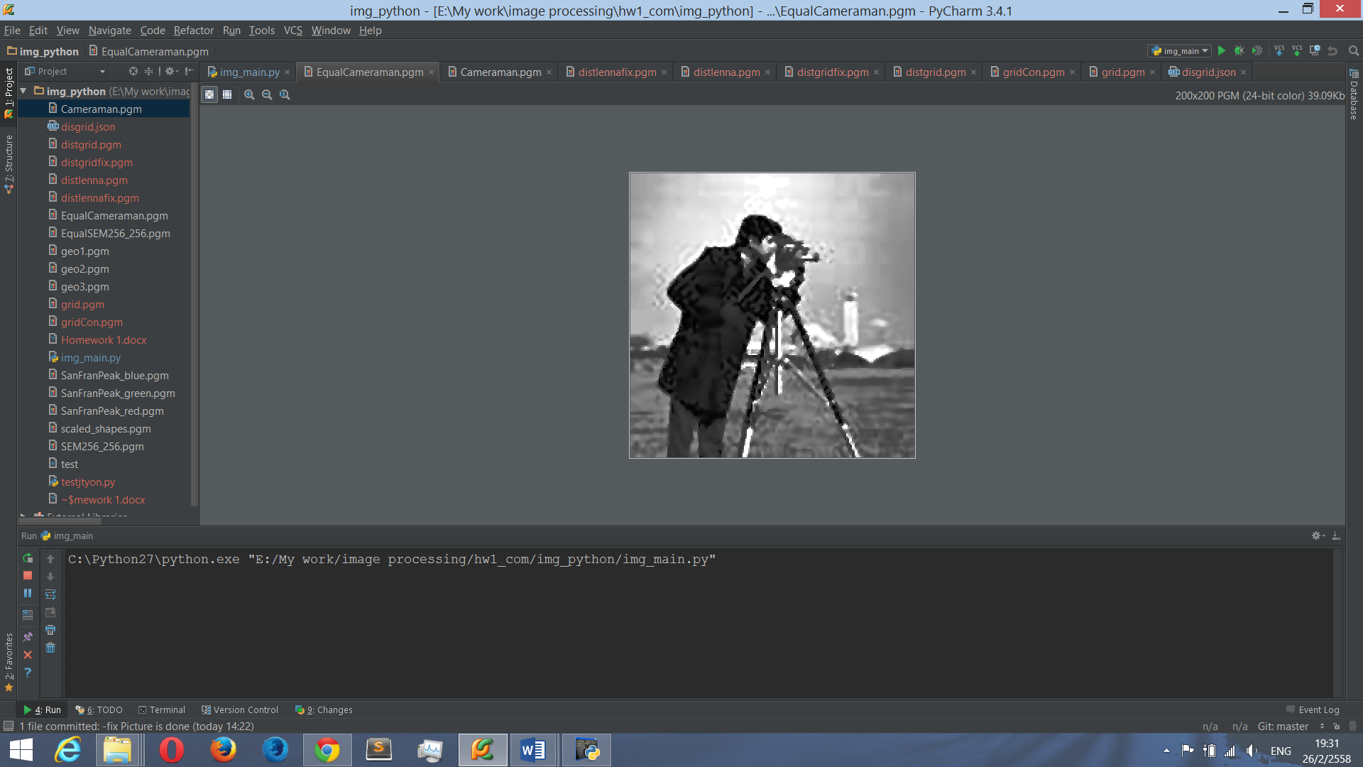

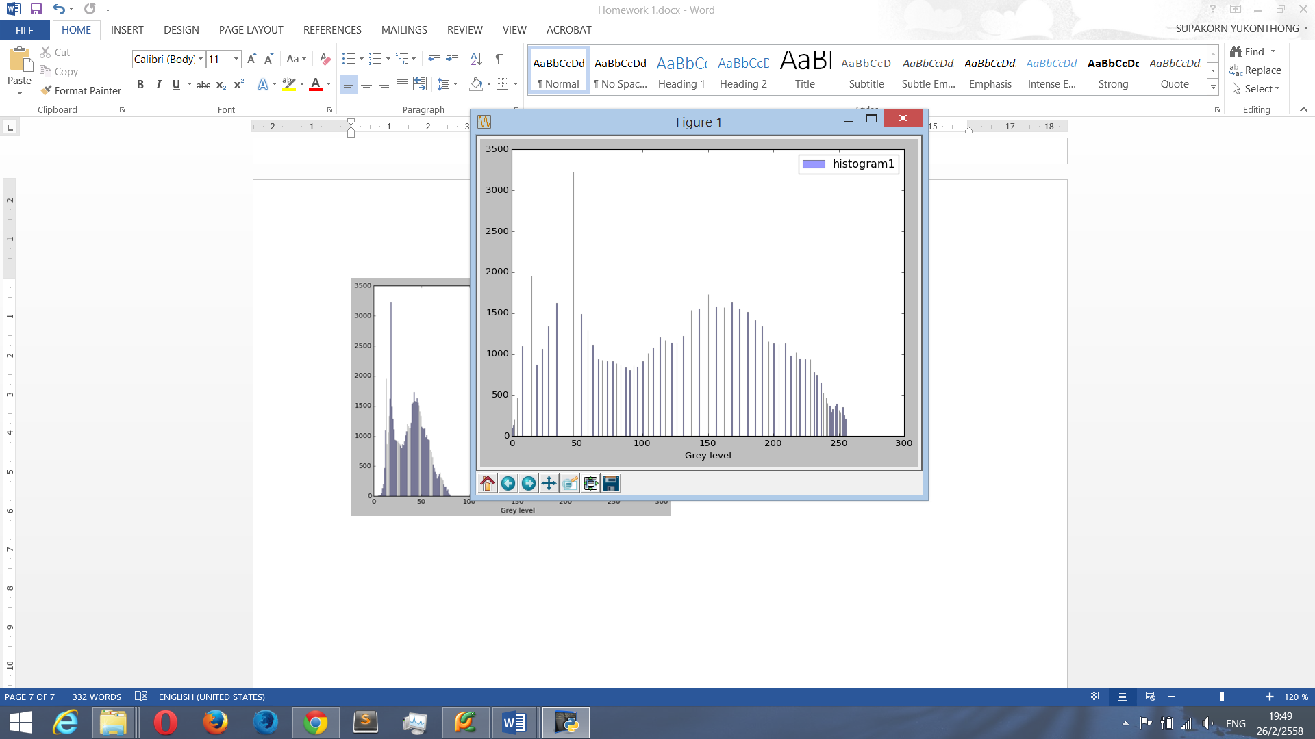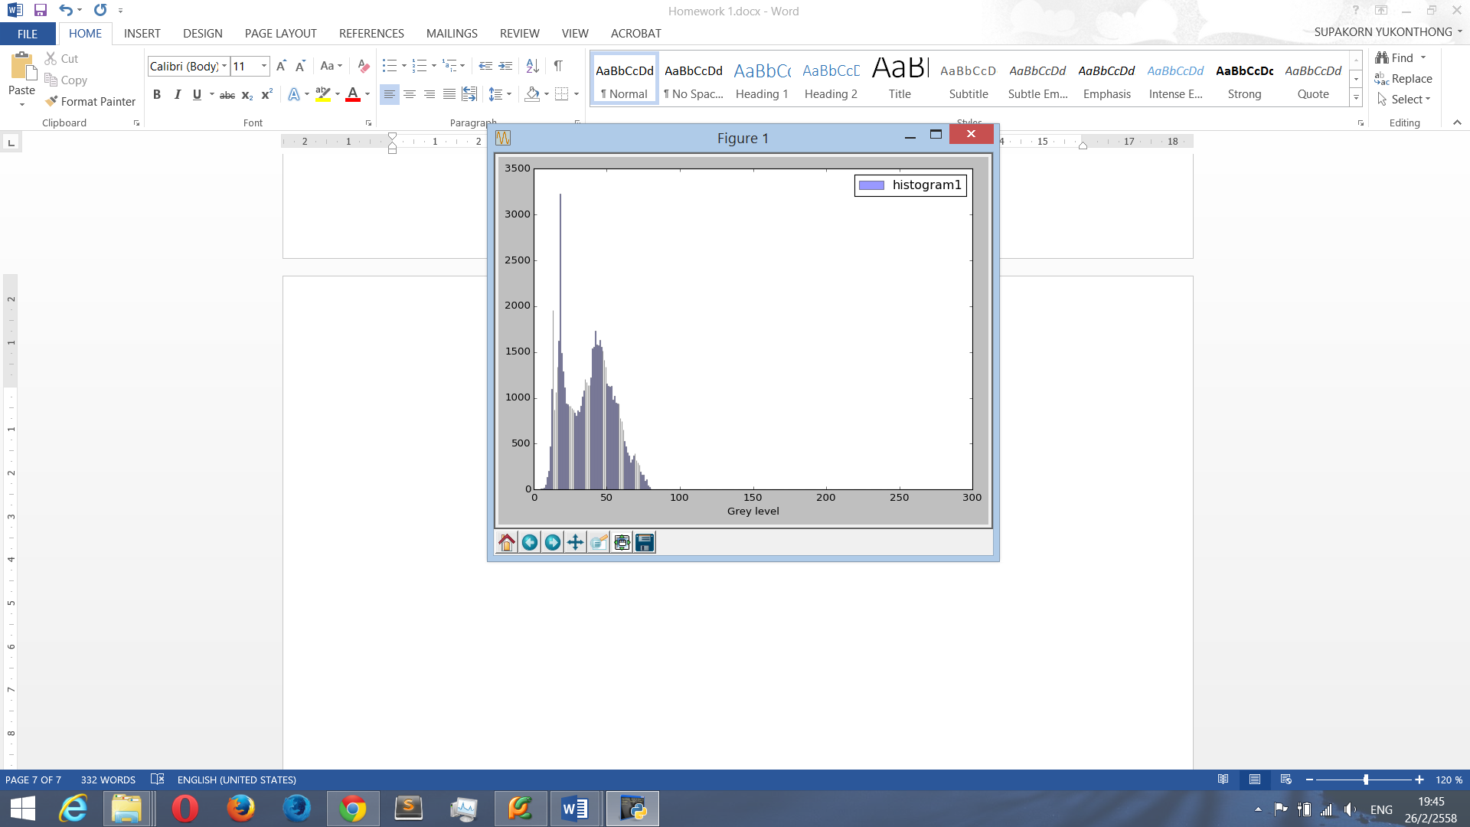

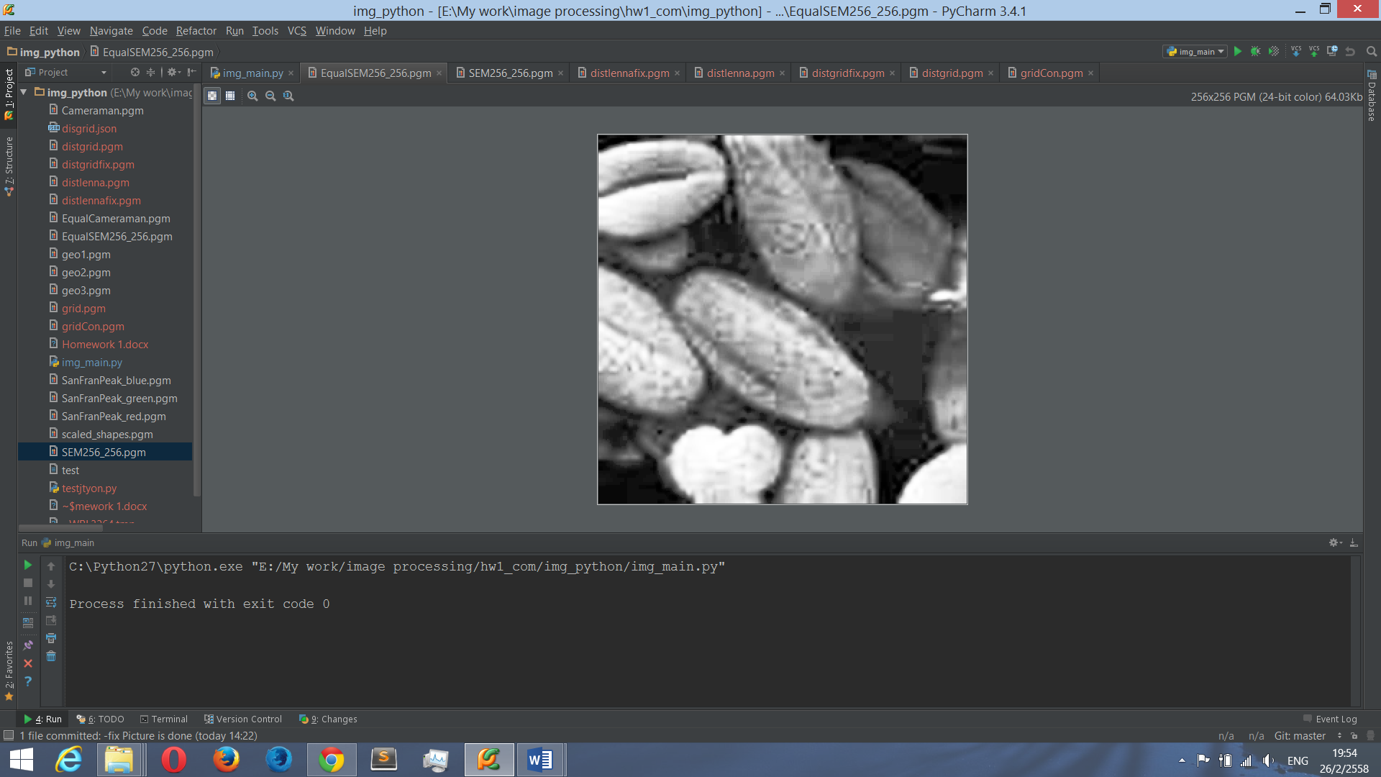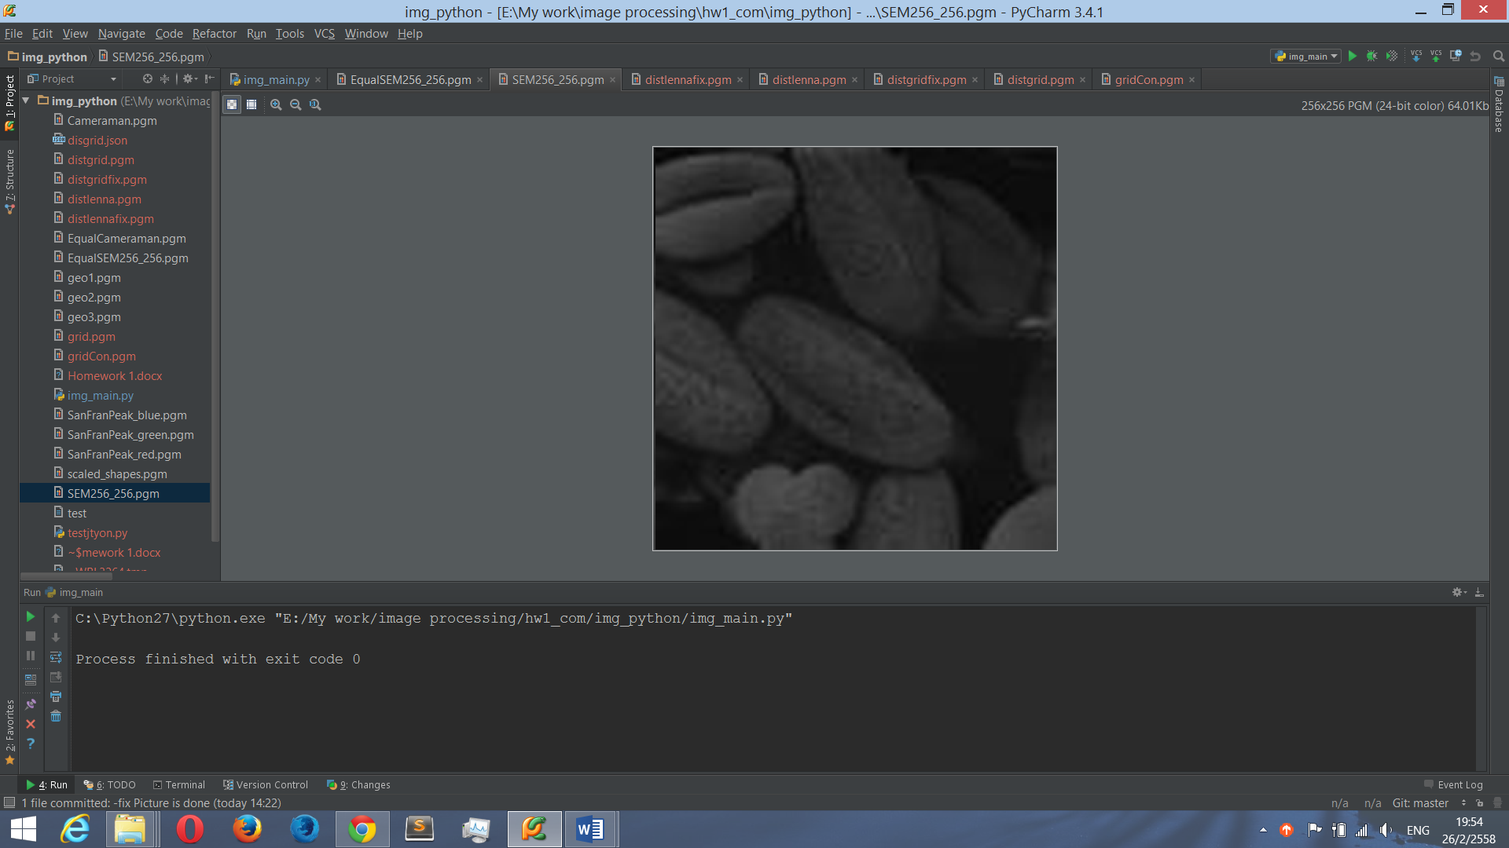

ผมเลือก Histogram Equalization ซึ่งเป็นหนึ่งใน Point Operation วิธีการนี้จะเกลี่ยค่า Histogram ให้เท่าๆกัน ทุก grey scale โดยใช้หลักการของ CDF มาช่วยในการหาความหนาแน่นของความน่าจะเป็นที่จะเกิดขึ้น หลังจากได้ค่า Histogram ใหม่มาแล้วก็ใช้วิธีปัดเศษ เพื่อให้ค่า pixel เก่าถูกปัดเข้า Grey level ใหม่ที่ได้มา

ดังนั้นจะสังเกตได้ว่าภาพ Cameraman.pgm นั้นมีความสว่างมากเกินไป หลังจากนำไปผ่าน Histogram Equalization ผลที่ได้จากการทำ จะทำให้ภาพมืดลง และเห็นลายละเอียดของภาพมากขึ้น

ส่วนภาพ SEM256_256.pgm นั้นมืดมากจนไม่เห็นลายละเอียดชัดเจนว่าเป็นรูปอะไร หลังจากนำไปผ่าน Histogram Equalization ผลที่ได้จากการทำ จะทำให้ภาพสว่างขึ้น และเห็นลายละเอียดของวัตถุมากขึ้น

1. Algebraic Operations

เป็นการดำเนินการคณิตศาสตร์กับ Pixel ของแต่ละสีโดยตรง

**Example code from my library**

myLib = ImageLib()

myLib.geometricOperationsImage("SanFranPeak_red","SanFranPeak_green","SanFranPeak_blue")

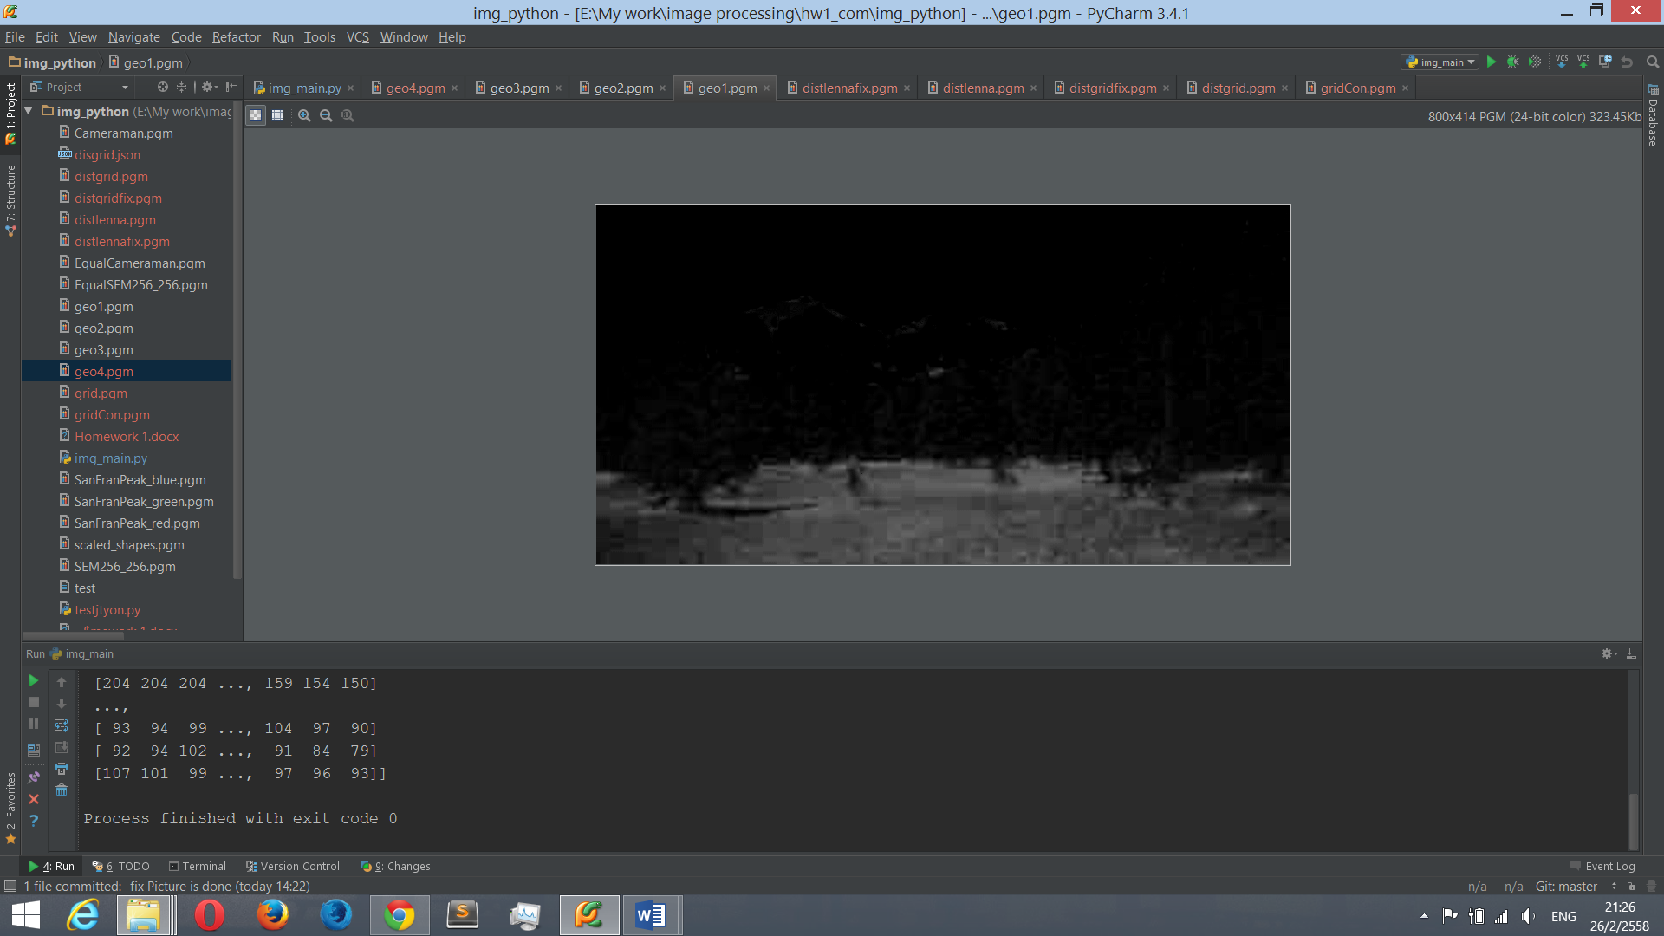

2g-r-b (excess green)

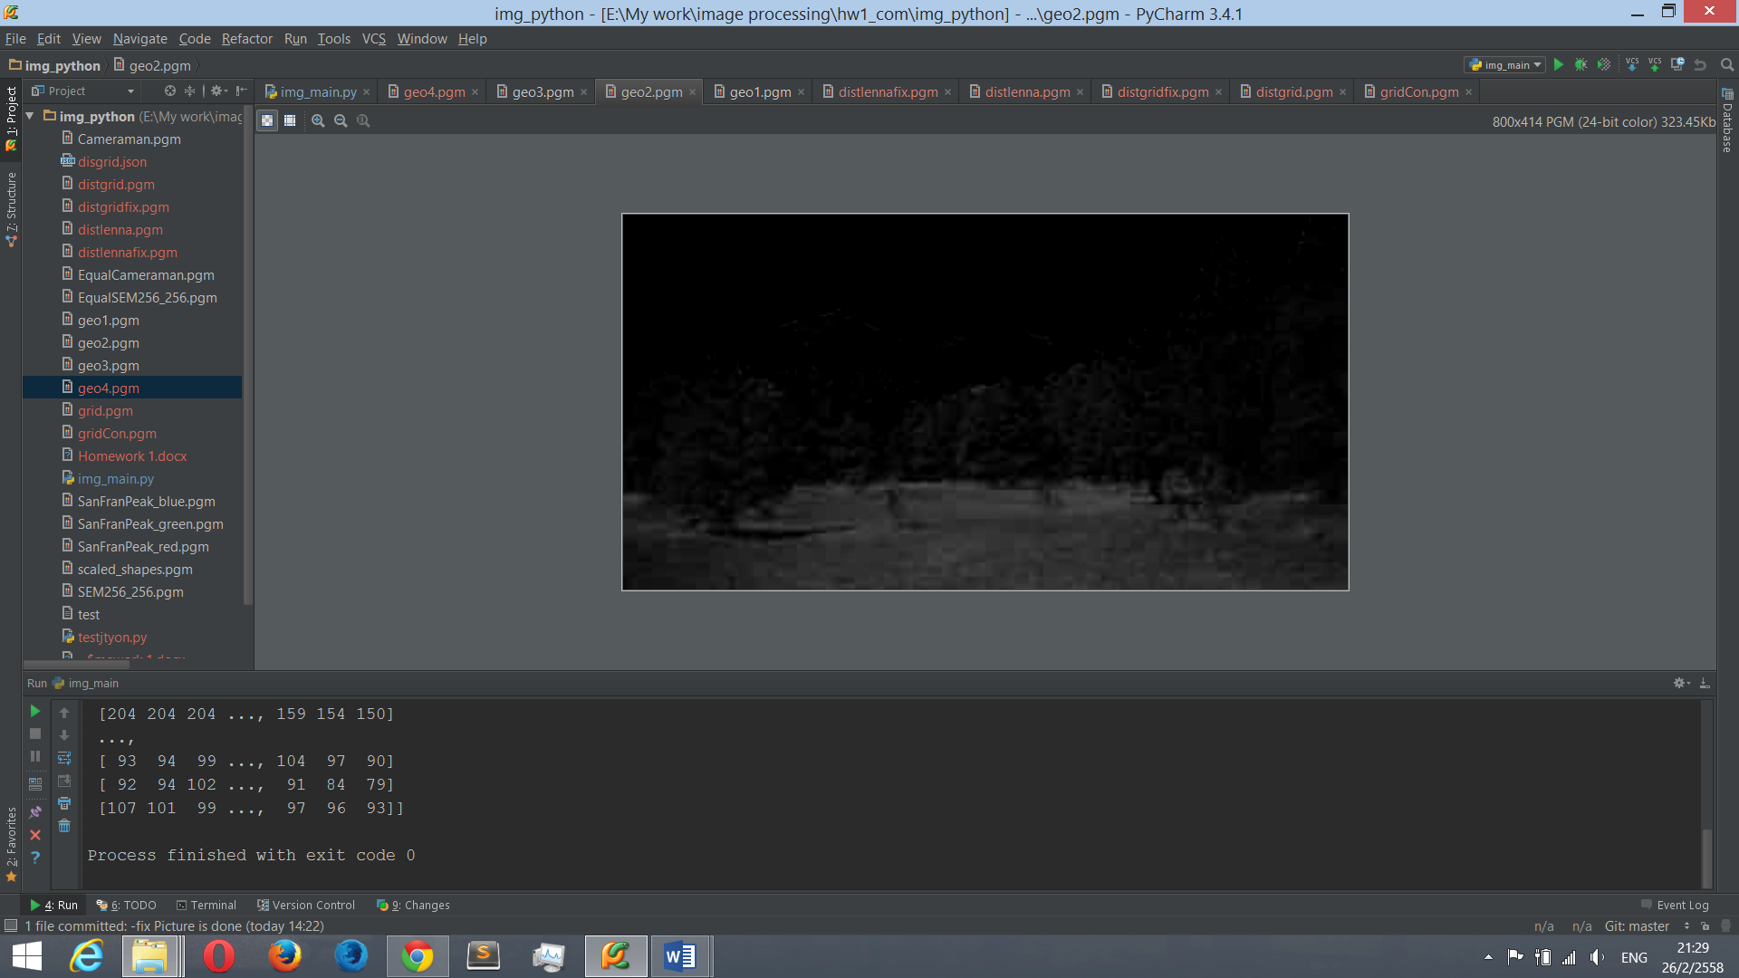

red-blue difference

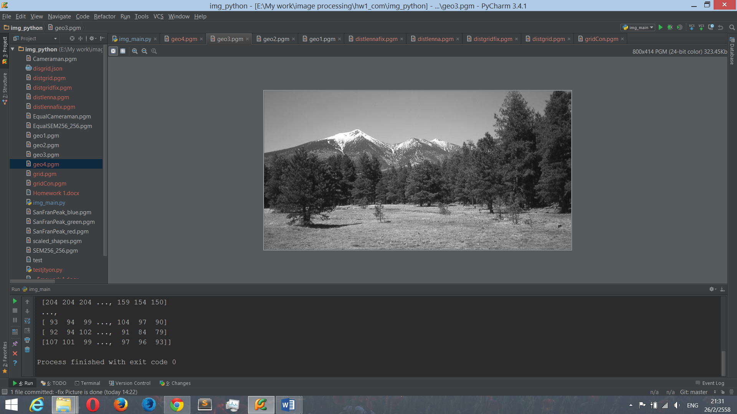

gray-level (intensity)

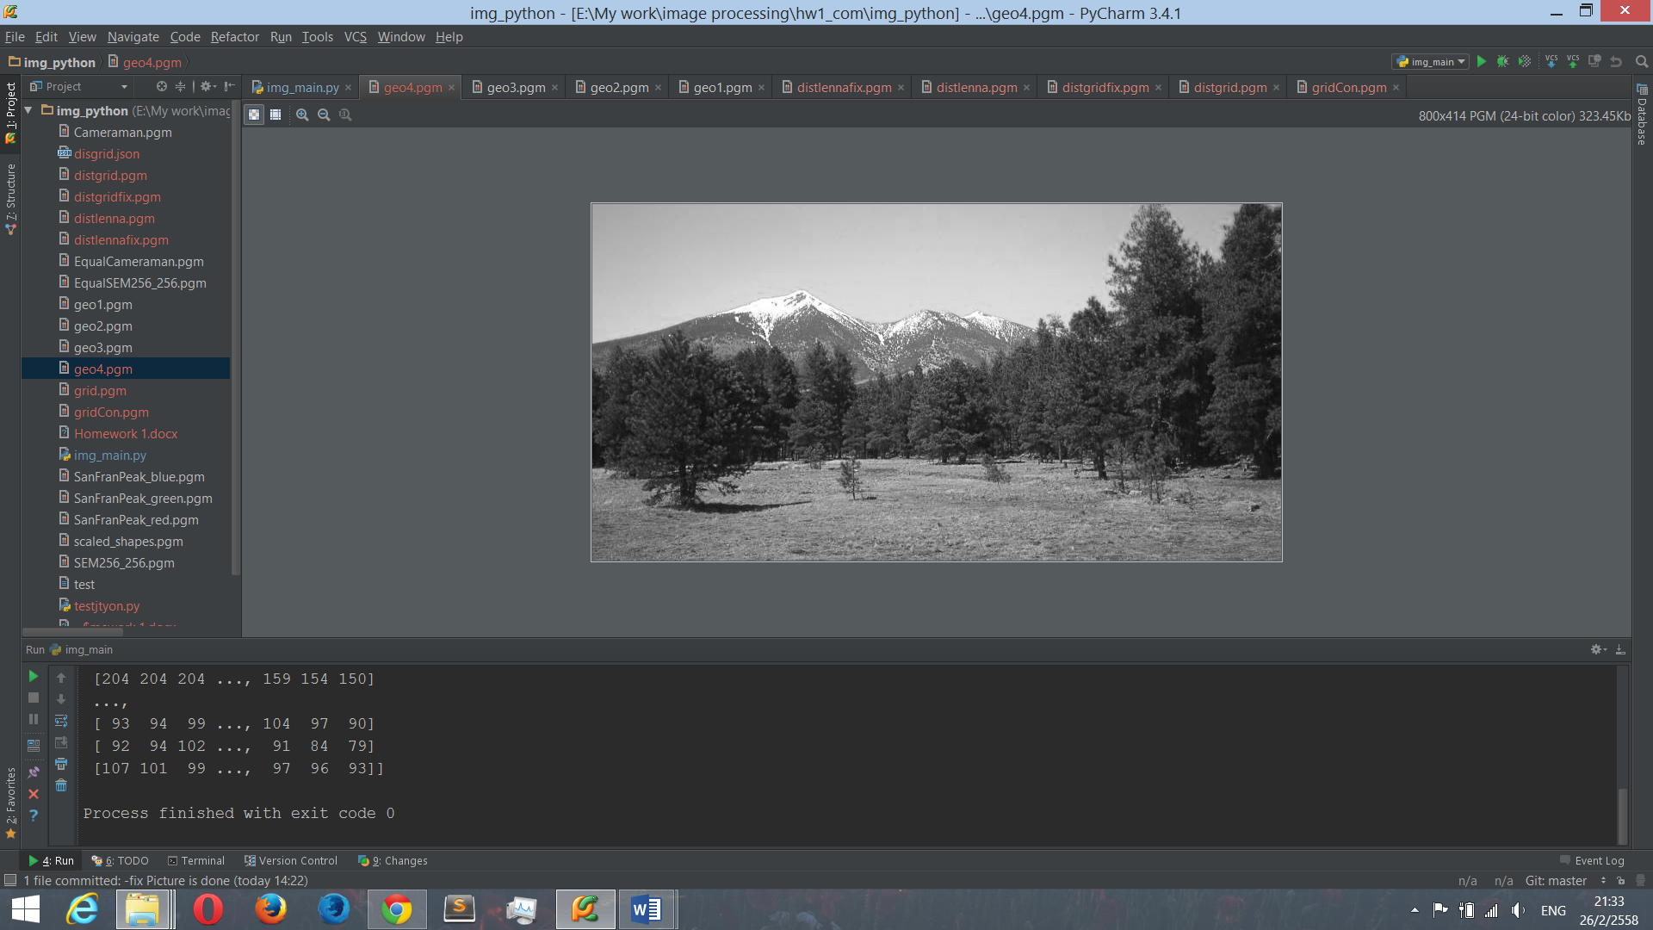

( ( (r+g)/2 ) + (2*b) )/3 เพิ่มโทนสีฟ้า

1. Geometric Operations

โจทย์กำหนดให้แปลงรูปเบี้ยวให้กลับมาเป็นรูปปกติ โดยเลือกใช้วิธี Control Grid Interpolation โดยผมมีขั้นตอนดำเนินการดังนี้

1. เนื่องจากเรามี File ที่มี ภาพ Grid ก่อนที่จะเบี้ยว ดังนั้นเราต้องหาตำแหน่งของแต่ละจุดนั้นคือ x1,y1,x2,y2,x3,y3,x4,y4 ของแต่ละ Grid ย่อย ผมเลือกใช้ Convolution กับ Kernel

$\begin{matrix}0 & 1 & 0 \\ 1 & 1 & 1 \\ 0 & 1 & 0\end{matrix}$

เราจะได้จุดพิกัดที่ตัดกันมีค่า Grey Level น้อยสุด จึงทำให้เราเห็นจุดสีเทาๆ และจุดที่ไม่ใช้จุดตัดจะมีค่า Grey Level สูงทำให้เราเห็นเป็นสีขาว หลังจากนั้นนำมาเติมจุดทางขวาและด้านล่างสุดให้ครบจำนวน Grid

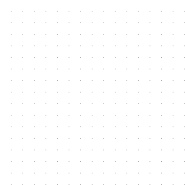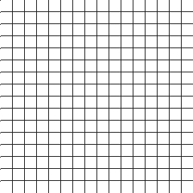

1. หลังจากนั้นก็นำค่าแต่ละตำแหน่งของแต่ล่ะ Grid ไปหาค่า w1,w2,w3,w4 เพื่อนำไปแทนสมการ
2. หลังจากนั้นก็สร้าง Array ชุดใหม่ขึ้นมาจำลองว่าเป็นรูปดี นำตำแหน่งในรูปดีที่เราต้องการไปแทนสมการ เราจะได้ตำแหน่ง Grey Level ของรูปเสียเพื่อนำไปแทนในรูปดี

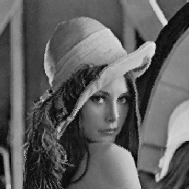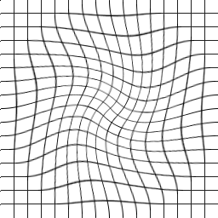

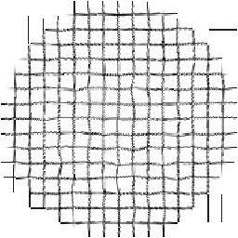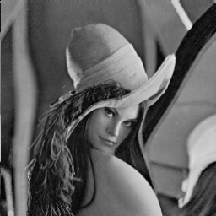

**Example code from my library**

myLib = ImageLib()

kernel = np.array([[0,1,0],[1,1,1],[0,1,0]])

pgmDataCon,pgmCon = myLib.convolutionWithKernel("grid",kernel)

normalGridPosition = myLib.findPixelPosition(pgmDataCon,256,256)

unNormalGridPosition = myLib.readJsonPixelPosition("disgrid.json")

xWeight,yWeight = myLib.findWeight(normalGridPosition,unNormalGridPosition)

myLib.fixBadPicture(xWeight,yWeight,"distgrid",normalGridPosition)

โค้ดทั้งหมดของผมครับอยู่ที่ File : img_main.py

Link บน Github ครับ 🡪 https://github.com/SupakornYu/ImageProcessingHW1.git

import numpy as np

import matplotlib.pyplot as plt

import math

import json

class ImageLib:

def readPGMImage(self,path): #Use for PGM File reading

file = open(path, "rb")

pgmVer = file.readline().split()

pgmComment = []

while True:

pgmComment_eachline = file.readline()

if(pgmComment_eachline[0]=="#"):

pgmComment.append(pgmComment_eachline)

else:

break

pgmSize = pgmComment_eachline.split()

pgmGreyscale = file.readline().split()

pgmDataList = []

htg = np.zeros((256),dtype=np.int32)

np.set_printoptions(suppress=True)

for j in range(int(pgmSize[1])):

pgmDataX = []

for i in range(int(pgmSize[0])):

byte = file.read(1)

chrToInt = ord(byte)

pgmDataX.append(chrToInt)

htg[chrToInt] = htg[chrToInt]+1

pgmDataList.append(pgmDataX)

file.close()

pgmData = np.asarray(pgmDataList,dtype=np.int32)

return pgmVer,pgmComment,pgmSize,pgmGreyscale,pgmData,htg

#pgmData is data pixel that i get from pgm file under grey level value(numpy array).

#pgmSize contain width and height of pixel(list).

#htg is a histogram of image (numpy array).

def plotHistogramFromArray(self,histogram_arr): #Use for histogram ploting

index = np.arange(256)

bar_width = 0.35

opacity = 0.4

rects1 = plt.bar(index, histogram_arr, bar_width,

alpha=opacity,

color='b',

label='histogram1')

plt.xlabel('Grey level')

plt.legend()

plt.tight_layout()

plt.show()

def countingObject(self,histogram,threshold_object): #Use for counting object

countObject = 0

countObjectGreyLevel = []

for i in range(histogram.size):

if histogram[i] >= threshold_object:

countObject += 1

countObjectGreyLevel.append(i)

countObjectGreyLevel.remove(max(countObjectGreyLevel))

return countObject-1,countObjectGreyLevel # minus 1 for backgroud

#def buildPGMInterestObject(self,inputFileName):

def pqMoment(self,p,q,pgmData,pgmSize,greyLevel,greyLevelSelected):

# Use for pq moment finding

moment = 0

pgmDataMoment = np.zeros((int(pgmSize[1]),int(pgmSize[0])), dtype=np.int32)

for i in range(int(pgmSize[1])):

for j in range(int(pgmSize[0])):

if pgmData[i][j] == greyLevelSelected:

pgmDataMoment[i][j] = 1

else:

pgmDataMoment[i][j] = 0

moment += ((math.pow(j,p))*((math.pow(i,q))*pgmDataMoment[i][j]))

#ImageLib.buildPGMFile(self,"testmoment",pgmSize[0],pgmSize[1],greyLevel,pgmDataMoment)

return moment,pgmDataMoment

def centralMoment(self,p,q,pgmData,pgmSize,greyLevel,greyLevelSelected):

centralMoment = 0

moment1,pgmDataMoment = ImageLib.pqMoment(self,1,0,pgmData,pgmSize,greyLevel,greyLevelSelected)

moment2,pgmDataMoment = ImageLib.pqMoment(self,0,1,pgmData,pgmSize,greyLevel,greyLevelSelected)

moment3,pgmDataMoment = ImageLib.pqMoment(self,0,0,pgmData,pgmSize,greyLevel,greyLevelSelected)

xCoor = moment1/moment3

yCoor = moment2/moment3

print "Central of Mass x : " + str(xCoor)

print "Central of Mass y : " + str(yCoor)

for i in range(int(pgmSize[1])):

for j in range(int(pgmSize[0])):

centralMoment += ((math.pow((j-xCoor),p))*((math.pow(i-yCoor,q))*pgmDataMoment[i][j]))

return centralMoment

def scaleInvariantMoment(self,p,q,pgmData,pgmSize,greyLevel,greyLevelSelected):

scaleInvariantMoment = 0

centralMomentPQ = ImageLib.centralMoment(self,p,q,pgmData,pgmSize,greyLevel,greyLevelSelected)

centralMoment00 = ImageLib.centralMoment(self,0,0,pgmData,pgmSize,greyLevel,greyLevelSelected)

scaleInvariantMoment = centralMomentPQ/(math.pow(centralMoment00,(1+((p+q)/2))))

return scaleInvariantMoment

def buildPGMFile(self,fileName,width,height,greyLevel,pgmData): #Write PGM File

f = open(str(fileName)+".pgm","wb")

f.write("P5\n");

f.write("# "+str(fileName)+"\n");

f.write(str(width)+" "+str(height)+"\n"+str(greyLevel[0])+"\n");

for i in range(int(height)):

for j in range(int(width)):

if pgmData[i][j]<0:

pgmData[i][j] = 0

elif pgmData[i][j]>int(greyLevel[0]):

pgmData[i][j] = int(greyLevel[0])

f.write(chr(pgmData[i][j]));

f.close()

def histogramEqualization(self,outputFileName,inputFileName):

pgmVer,pgmComment,pgmSize,pgmGreyscale,pgmData,htg = ImageLib.readPGMImage(self,str(inputFileName)+".pgm")

ImageLib.plotHistogramFromArray(self,htg)

imgArea = int(pgmSize[0])*int(pgmSize[1])

htgScaleAfter = np.zeros(int(pgmGreyscale[0])+1,dtype=np.int32)

propOfA = 0.0

for i in range(htg.size):

propOfA += float(htg[i])/float(imgArea)

#print "propA" + str(propOfA)

fDa = propOfA * float(pgmGreyscale[0])

htgScaleAfter[i] = round(fDa)

pgmDataAfter = np.zeros((int(pgmSize[1]),int(pgmSize[0])),dtype=np.int32)

for i in range(int(pgmSize[1])):

for j in range(int(pgmSize[0])):

pgmDataAfter[i][j] = htgScaleAfter[pgmData[i][j]]

ImageLib.buildPGMFile(self,outputFileName,pgmSize[0],pgmSize[1],pgmGreyscale,pgmDataAfter)

pgmVer,pgmComment,pgmSize,pgmGreyscale,pgmData,htg = ImageLib.readPGMImage(self,str(outputFileName)+".pgm")

ImageLib.plotHistogramFromArray(self,htg)

def geometricOperationsImage(self,redPgmFileName,greenPgmFileName,bluePgmFileName):

redpgmVer,redpgmComment,redpgmSize,redpgmGreyscale,redpgmData,redhtg = ImageLib.readPGMImage(self,str(redPgmFileName)+".pgm")

greenpgmVer,greenpgmComment,greenpgmSize,greenpgmGreyscale,greenpgmData,greenhtg = ImageLib.readPGMImage(self,str(greenPgmFileName)+".pgm")

bluepgmVer,bluepgmComment,bluepgmSize,bluepgmGreyscale,bluepgmData,bluehtg = ImageLib.readPGMImage(self,str(bluePgmFileName)+".pgm")

print redpgmData

print greenpgmData

print bluepgmData

geo1 = ((2*redpgmData)-greenpgmData)-bluepgmData

ImageLib.buildPGMFile(self,"geo1",redpgmSize[0],redpgmSize[1],redpgmGreyscale,geo1)

geo2 = (redpgmData-bluepgmData)

ImageLib.buildPGMFile(self,"geo2",redpgmSize[0],redpgmSize[1],redpgmGreyscale,geo2)

geo3 = (redpgmData+greenpgmData+bluepgmData)/3

ImageLib.buildPGMFile(self,"geo3",redpgmSize[0],redpgmSize[1],redpgmGreyscale,geo3)

geo4 = (((redpgmData+greenpgmData)/2)+2*bluepgmData)/3 #my own option

ImageLib.buildPGMFile(self,"geo4",redpgmSize[0],redpgmSize[1],redpgmGreyscale,geo4)

def convolutionWithKernel(self,inputFileName,kernel):

pgmVer,pgmComment,pgmSize,pgmGreyscale,pgmData,htg = ImageLib.readPGMImage(self,str(inputFileName)+".pgm")

pgmDataCon = np.zeros((int(pgmSize[1]),int(pgmSize[0])),dtype=np.int32)

pgmDataCon.fill(255)

#print pgmData

for i in range(1,int(pgmSize[1])-1):

for j in range(1,int(pgmSize[0])-1):

temp = 0

#XYY

#YYY

#YYY

temp += pgmData[i][j]*kernel[1][1]

temp += pgmData[i-1][j-1]*kernel[0][0]

temp += pgmData[i-1][j]*kernel[0][1]

temp += pgmData[i+1][j+1]*kernel[2][2]

temp += pgmData[i][j-1]*kernel[1][0]

temp += pgmData[i][j+1]*kernel[1][2]

temp += pgmData[i+1][j-1]*kernel[2][0]

temp += pgmData[i+1][j]*kernel[2][1]

temp += pgmData[i+1][j+1]*kernel[2][2]

pgmDataCon[i][j] = temp

pgmCon = np.array(pgmDataCon)

#extend grid

for i in range(15,int(pgmSize[1]),16):

pgmDataCon[255][i] = 160

pgmDataCon[i][255] = 160

ImageLib.buildPGMFile(self,str(inputFileName)+"Con",pgmSize[0],pgmSize[1],pgmGreyscale,pgmDataCon)

return pgmDataCon,pgmCon

def readJsonPixelPosition(self,fileName):

json_data=open(fileName)

data = json.load(json_data)

json_data.close()

#print data[0]["y"+str(4)]

return data

def findPixelPosition(self,convoluteArr,width,height):

normalGridPosition = []

count = 0

for i in range(height):

for j in range(width):

if(convoluteArr[i][j]==160):

dict = {'u': count,'x1': j-15,'y1': i-15,'x2':j,'y2': i-15,'x3': j-15,'y3': i,'x4': j,'y4': i}

normalGridPosition.append(dict)

count +=1

return normalGridPosition

def findWeight(self,goodGrid,badGrid):

xWeight = []

yWeight = []

for i in range(256):

a = np.array([[ goodGrid[i]['x1'],goodGrid[i]['y1'],goodGrid[i]['x1']*goodGrid[i]['y1'],1 ],[ goodGrid[i]['x2'],goodGrid[i]['y2'],goodGrid[i]['x2']*goodGrid[i]['y2'],1 ],[ goodGrid[i]['x3'],goodGrid[i]['y3'],goodGrid[i]['x3']*goodGrid[i]['y3'],1 ],[ goodGrid[i]['x4'],goodGrid[i]['y4'],goodGrid[i]['x4']*goodGrid[i]['y4'],1 ]])

b = np.array([badGrid[i]['x1'],badGrid[i]['x2'],badGrid[i]['x3'],badGrid[i]['x4']])

x = np.linalg.solve(a, b)

xWeight.append(x)

a = np.array([[ goodGrid[i]['x1'],goodGrid[i]['y1'],goodGrid[i]['x1']*goodGrid[i]['y1'],1 ],[ goodGrid[i]['x2'],goodGrid[i]['y2'],goodGrid[i]['x2']*goodGrid[i]['y2'],1 ],[ goodGrid[i]['x3'],goodGrid[i]['y3'],goodGrid[i]['x3']*goodGrid[i]['y3'],1 ],[ goodGrid[i]['x4'],goodGrid[i]['y4'],goodGrid[i]['x4']*goodGrid[i]['y4'],1 ]])

b = np.array([badGrid[i]['y1'],badGrid[i]['y2'],badGrid[i]['y3'],badGrid[i]['y4']])

y = np.linalg.solve(a, b)

yWeight.append(y)

return xWeight,yWeight

def fixBadPicture(self,xWeight,yWeight,badPictureFileName,goodGrid):

pgmVer,pgmComment,pgmSize,pgmGreyscale,pgmData,htg = ImageLib.readPGMImage(self,str(badPictureFileName)+".pgm")

pgmFixedPicture = np.zeros((int(pgmSize[1]),int(pgmSize[0])), dtype=np.int32)

for k in goodGrid:

#print k

for i in range(k['y1'],k['y4']+1):

for j in range(k['x1'],k['x4']+1):

xAxis = round((xWeight[k['u']][0]*j) + (xWeight[k['u']][1]*i) + (xWeight[k['u']][2]*i*j) + (xWeight[k['u']][3]),1)

yAxis = round((yWeight[k['u']][0]*j) + (yWeight[k['u']][1]*i) + (yWeight[k['u']][2]*i*j) + (yWeight[k['u']][3]),1)

"""

if xAxis >=255 or yAxis >=255:

xAxis = 255

yAxis = 255

print "over"

elif xAxis <=0 or yAxis <=0:

xAxis = 0

yAxis = 0

print "less"

"""

pgmFixedPicture[i][j] = pgmData[yAxis][xAxis]

"""

print "i " + str(i)

print "j " + str(j)

print "x " + str(xAxis)

print "y " + str(yAxis)

print "xW " + str(xWeight[k['u']])

print "yW " + str(yWeight[k['u']])

print "u " + str(k['u'])

"""

ImageLib.buildPGMFile(self,str(badPictureFileName)+"fix",pgmSize[0],pgmSize[1],pgmGreyscale,pgmFixedPicture)

# under this line is for solving each problem

"""

#4

myLib = ImageLib()

#myLib.readJsonPixelPosition("disgrid.json")

kernel = np.array([[0,1,0],[1,1,1],[0,1,0]])

print kernel

#np.set_printoptions(threshold=np.nan)

pgmDataCon,pgmCon = myLib.convolutionWithKernel("grid",kernel)

#print np.amax(pgmCon) #find max value

#print np.unique(pgmDataCon) #find number

#np.set_printoptions(threshold=np.nan)

#print pgmDataCon

#print pgmCon

normalGridPosition = myLib.findPixelPosition(pgmDataCon,256,256)

unNormalGridPosition = myLib.readJsonPixelPosition("disgrid.json")

#print normalGridPosition

#print unNormalGridPosition[255]['x2']

#print normalGridPosition[255]['x2']

xWeight,yWeight = myLib.findWeight(normalGridPosition,unNormalGridPosition)

#print xWeight

#print yWeight

myLib.fixBadPicture(xWeight,yWeight,"distgrid",normalGridPosition)

"""

"""

#3

myLib = ImageLib()

myLib.geometricOperationsImage("SanFranPeak_red","SanFranPeak_green","SanFranPeak_blue")

"""

"""

#2

myLib = ImageLib()

myLib.histogramEqualization("EqualCameraman","Cameraman")

myLib.histogramEqualization("EqualSEM256_256","SEM256_256")

"""

"""

#1.1

myLib = ImageLib()

pgmVer,pgmComment,pgmSize,pgmGreyscale,pgmData,htg = myLib.readPGMImage('scaled_shapes.pgm')

#myLib.buildPGMFile("test",pgmSize[0],pgmSize[1],pgmGreyscale,pgmData)

print htg

#monent,pgmDataMoment = myLib.pqMoment(1,1,pgmData,pgmSize,pgmGreyscale,255)

print "object : "+ str(myLib.countingObject(htg,1000))

myLib.plotHistogramFromArray(htg)

"""

"""

#1.2

myLib = ImageLib()

pgmVer,pgmComment,pgmSize,pgmGreyscale,pgmData,htg = myLib.readPGMImage('scaled_shapes.pgm')

print myLib.pqMoment(0,2,pgmData,pgmSize,pgmGreyscale,200) #return pq-moment

print myLib.centralMoment(0,2,pgmData,pgmSize,pgmGreyscale,200) #return central moment

print myLib.scaleInvariantMoment(2,0,pgmData,pgmSize,pgmGreyscale,200)+myLib.scaleInvariantMoment(0,2,pgmData,pgmSize,pgmGreyscale,200)

"""